Tax Planning Social Media Copy Options
- It’s been a strange year. Make sure you take note of potential tax implications. #incometax #finances [use CBSI’s shortened link for campaign branded infographic] OR [credit union insert shortened link to blog page or hosted PDF/JPG]
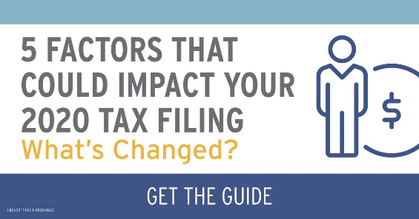
(download post image here)

- Do you have to pay income tax on that stimulus payment? How about the extra $600 for unemployment? Get answers in our quick guide. #incometax #finances [use CBSI’s shortened link for campaign branded infographic] OR [credit union insert shortened link to blog page or hosted PDF/JPG]
(download post image here)

- There have been a lot of changes to tax laws this year. How do they impact you? Get the guide. #incometax #finances [use CBSI’s shortened link for campaign branded infographic] OR [credit union insert shortened link to blog page or hosted PDF/JPG]
(download post image here)

CBSI-3211167.1-0820-0922

