Life Insurance Protection Social Media Copy Options
- Have you been thinking about life insurance? Here’s how to know whether now may be the right time. #lifeinsurance [use CBSI’s shortened link for campaign branded infographic: https://bit.ly/34DcA1g] OR [credit union insert shortened link to blog page or hosted PDF/JPG]
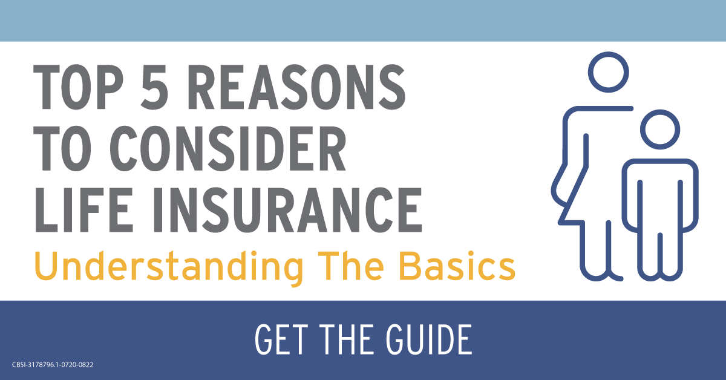
(download blue/yellow post image here), (download blue/green post image here), (download burgundy post image here)

- What’s the difference between term life and permanent life insurance? And which one is right for you? Use this guide to bring some clarity. #lifeinsurance [use CBSI’s shortened link for campaign branded infographic: https://bit.ly/34DcA1g] OR [credit union insert shortened link to blog page or hosted PDF/JPG]
(download blue/yellow post image here), (download blue/green post image here), (download burgundy post image here)

- We get it. Life insurance is an uncomfortable topic. But this guide can help you know whether now is the right time to take a closer look. #lifeinsurance [use CBSI’s shortened link for campaign branded infographic: https://bit.ly/34DcA1g] OR [credit union insert shortened link to blog page or hosted PDF/JPG]
(download blue/yellow post image here), (download blue/green post image here), (download burgundy post image here)
CBSI-3178796.1-0720-0822

