Diversification Social Media Copy Options
- What do you do when your retirement savings take a hit? Use these tips to plan for the long haul. #investmenttips #retirementplanning [use CBSI’s shortened link for campaign branded infographic: https://bit.ly/2ErczCf] OR [credit union insert shortened link to blog page or hosted PDF/JPG]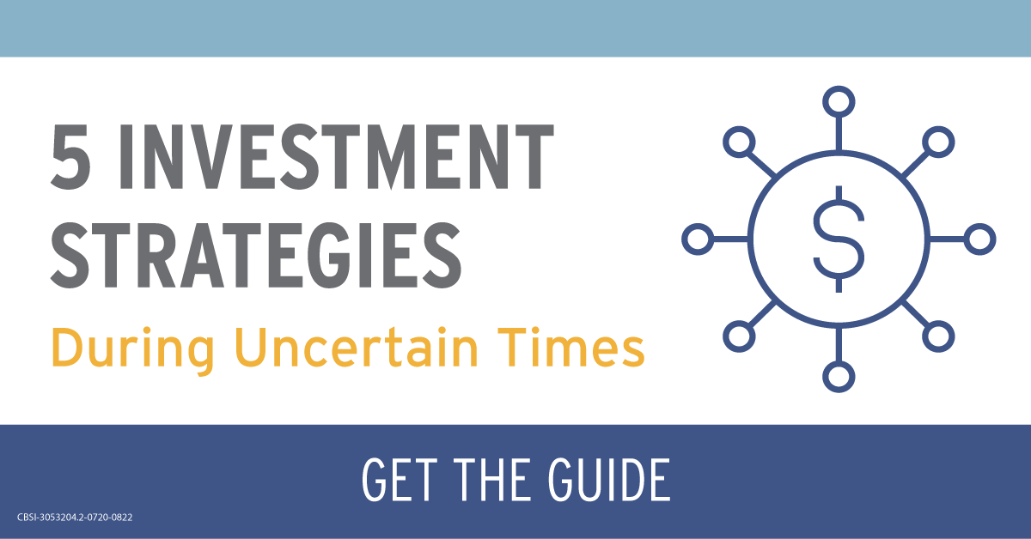
(download blue/yellow post image here), (download blue/green post image here), (download burgundy post image here)

- We live in a different world and retirement may not look the same as it did a couple months ago. Now what? Here are some tips. #investmenttips #retirementplanning [use CBSI’s shortened link for campaign branded infographic: https://bit.ly/2ErczCf] OR [credit union insert shortened link to blog page or hosted PDF/JPG]
(download blue/yellow post image here), (download blue/green post image here), (download burgundy post image here)

- Wondering how to plan for the future when things seem uncertain? You’re not alone. These tips may help. #investmenttips #retirementplanning [use CBSI’s shortened link for campaign branded infographic: https://bit.ly/2ErczCf] OR [credit union insert shortened link to blog page or hosted PDF/JPG]
(download blue/yellow post image here), (download blue/green post image here), (download burgundy post image here)
CBSI-3053204.2-0720-0822

